Flower Child Plano
2101 Preston Rd
Plano, TX 75093
11 a.m. - 9 p.m. Daily
iamaflowerchild.com
Instagram • Facebook
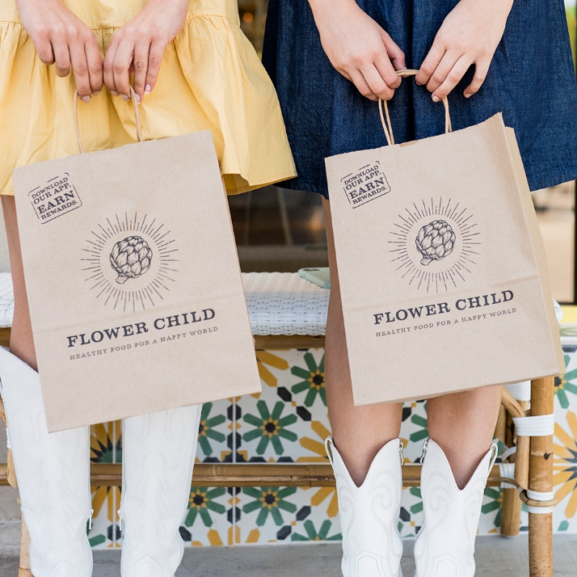
High-res images are available here.

FLOWER CHILD SPREADING THEIR GOOD-FOR-YOU MISSION TO PLANO
Flower Child, the fast-casual restaurant designed to inspire and support healthy lifestyles, will open in Plano on January 30. The popular restaurant from Fox Restaurant Concepts offers a deliciously wide-ranging menu that caters to all dietary lifestyles, from vegetarian and vegan to guilt-free cravings and everything in between. The menu also features a selection of signature lemonades and kombucha on tap, along with wine, seasonal sangrias, and local craft beers.

Flower Child is known for its diverse selection of salads, bowls, entrées, wraps, delicious sides, and seasonal fan favorites. Guests with any diet or craving can mix and match combinations of seasonal vegetables, fruits, and grains with proteins such as chicken, salmon, steak, shrimp, and tofu. Flower Child’s menu includes good-for-you eats suitable for all tastes and preferences, from year-round healthy goodness to limited seasonal indulgences.

To celebrate the grand opening, Flower Child will partner with The Autism Community in Action (TACA), which provides education, support, and hope to families living with autism by donating 10 percent of all opening day sales to the organization. Guests will also have the chance to win a $1,000 Flower Child gift card during opening week. Download the new-and-improved Flower Child app and place an order to enter. Be sure to stop by opening day to receive an exclusive Plano Flower Child sticker, available while supplies last.

Additionally, Flower Child is now hiring numerous positions for both the front and back of the house at its Plano location. The concept is looking for positive people passionate about hospitality, healthy living, intuitive eating, and positive attitudes. Available positions include fast casual server, line cook, prep cook, and dishwasher. Those interested can apply in person at Flower Child’s upcoming Job Fair on January 9 – 20 from 10 a.m. – 6 p.m., excluding Sunday, January 14.

About Flower Child
Flower Child is a fast-casual restaurant designed to inspire and support healthy lifestyles. As a part of Sam Fox’s Fox Restaurant Concepts, the multi-location restaurant provides made-from-scratch meals that are accessible to a variety of dietary needs. Flower Child’s menu offers customizable bowls, wraps, salads, and different mix-and-match veggies, grains, fruits, and healthy proteins, offering clean eating with convenience. Known for its cheerful staff and uplifting dining environment, Flower Child has locations in Arizona, California, Colorado, Georgia, Maryland, Nevada, Oklahoma, North Carolina, Texas, Virginia, and Washington D.C. For more information, please visit www.iamaflowerchild.com or follow @eatflowerchild.
About Fox Restaurant Concepts (FRC)
Fox Restaurant Concepts' story begins with Sam Fox, a man passionate about hospitality and endlessly inspired by food and design. He opened his first concept, Wildflower American Cuisine, in Tucson in 1998, and today has introduced dozens of ever-evolving Fox Restaurant Concepts brands, including The Henry, North Italia, Blanco Cocina + Cantina, Culinary Dropout, and Flower Child. Now, 25 years later, the group has 12 unique concepts with over 60+ locations across the U.S. The Fox Restaurants team is a community of creative thinkers who help bring Sam’s concepts to life. Starting in its Home Office in Phoenix (also known as the “Big Kitchen”), the team immerses itself in every detail. It develops each idea into fully-fledged, brick-and-mortar restaurant experiences nationwide. With a love for bringing passionate people and big ideas together, creating unique experiences, and sharing stories over incredible food, Fox Restaurant Concepts sees every brand as a way to connect with and serve those who matter most—their people and guests. For more information, visit www.foxrc.com.

